**Name: Muhammad Usman**

**Roll No: 22i-0900**

**Section: CS-D3**

**Task 1**

.386

.model flat,stdcall

.stack 4096

.data

n1 dw 10000111b ;135

n2 dw 10000010b ;130

n3 dw 1010010b ;82

n4 dw 1000010b ;66

.code

main PROC

mov ax,0

mov ax,n1

add ax,n2

mov ax,0

mov ax,n3

add ax,n4

mov ax,0

main ENDP

end main

for n1 and n2

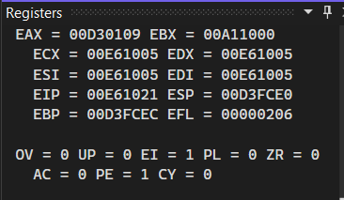

For n3 and n4

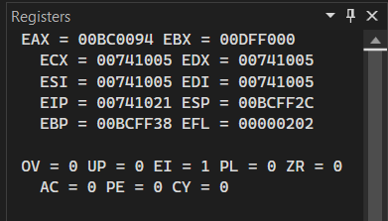

**Task 2**

.386

.model flat,stdcall

.stack 4096

.data

n1 dw 25

n2 dw 19

n3 dw 125

n4 dw 125

n5 dw 155

n6 dw 14

.code

main PROC

mov ax,0

mov ax,n2

sub ax,n1

mov ax,0

mov ax,n4

sub ax,n3

mov ax,0

mov ax,n6

sub ax,n5

mov ax,0

main ENDP

end main

1. 25,19

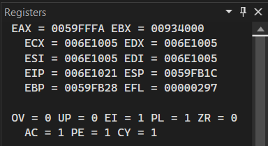

1. 125,125

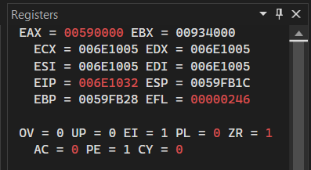

1. 155,14

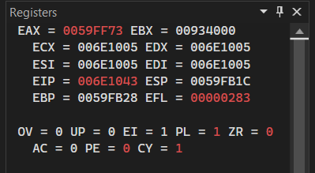

**Task 3**

.386

.model flat,stdcall

.stack 4096

.data

arr dw ?

count dw 0

.code

main PROC

mov ecx,11

mov ax,0

L1: mov arr,ax

add count,2

add ax,2

loop L1

main ENDP

end main

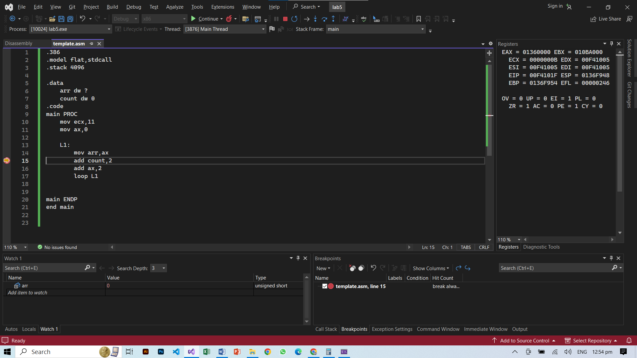 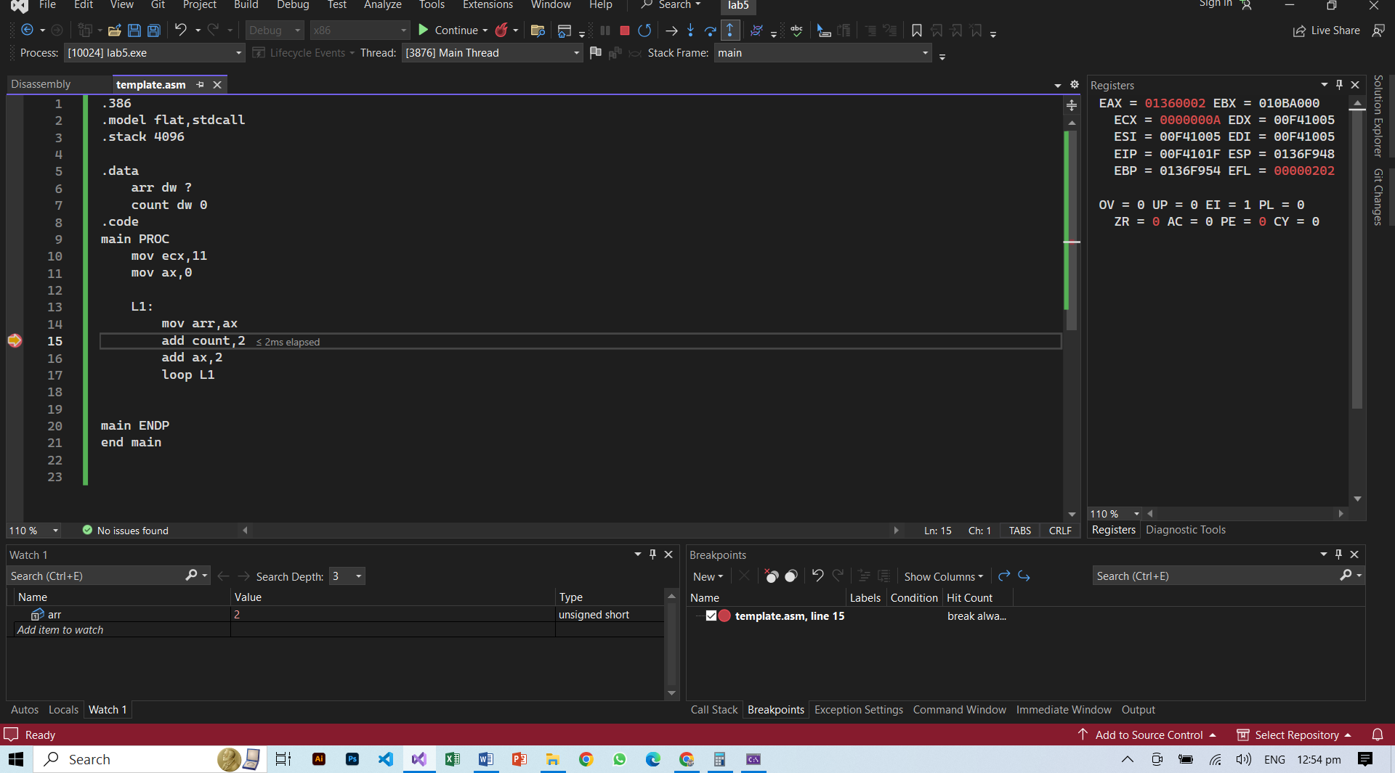 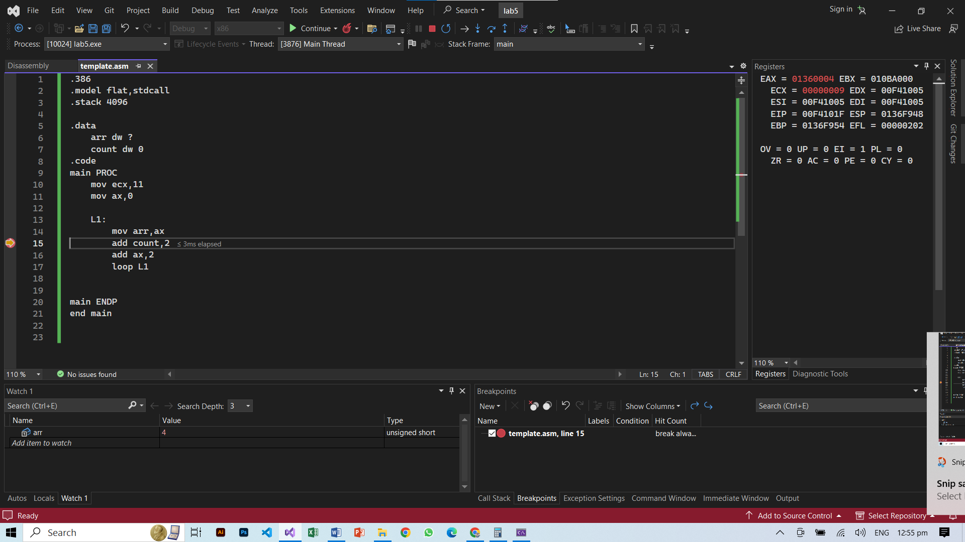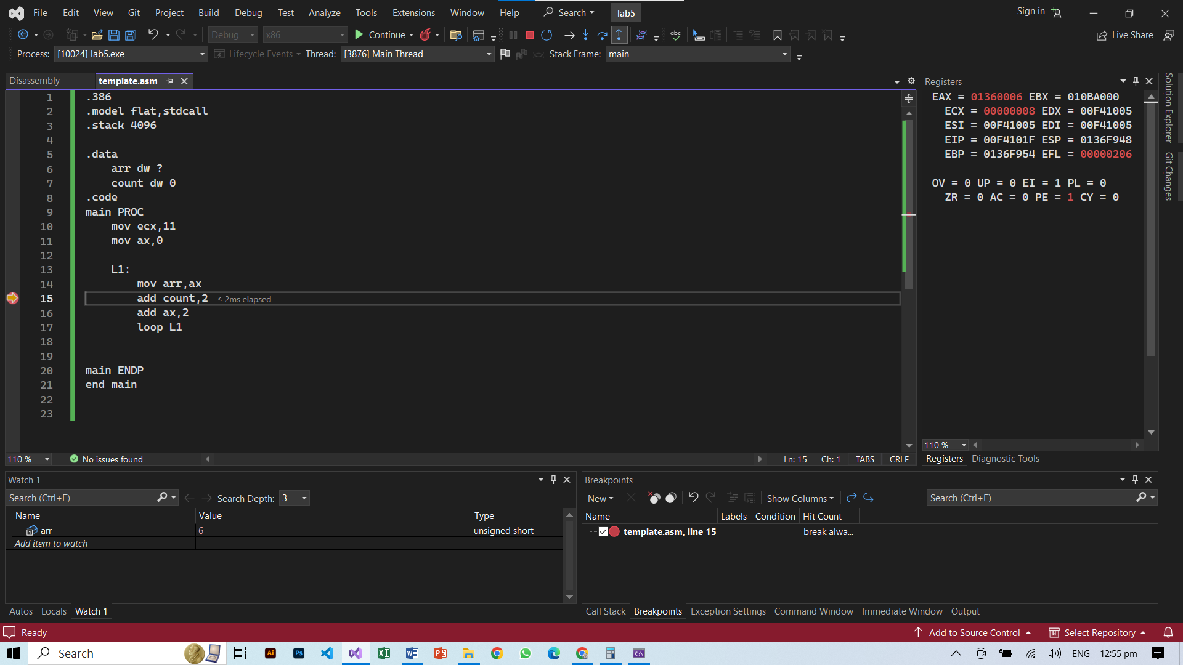 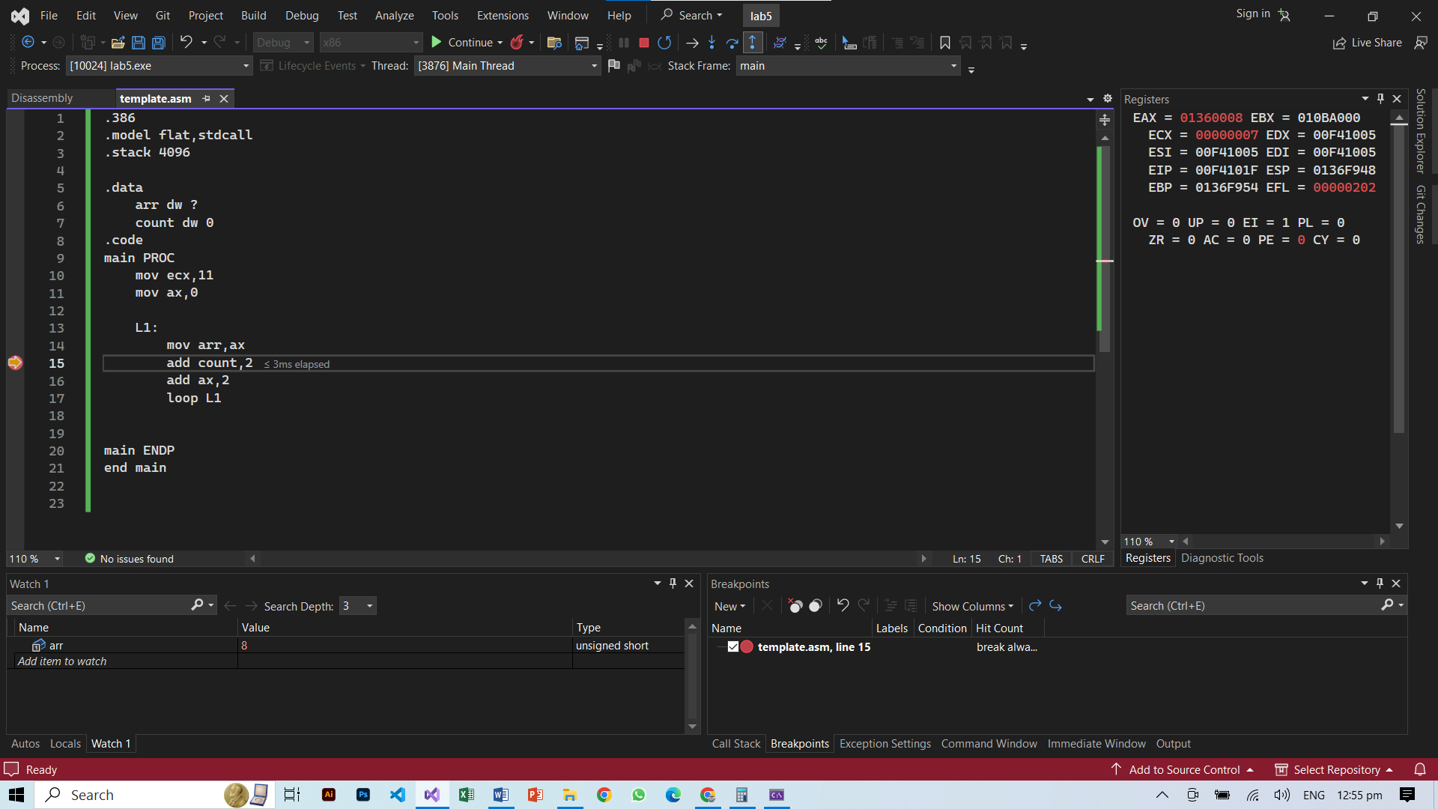 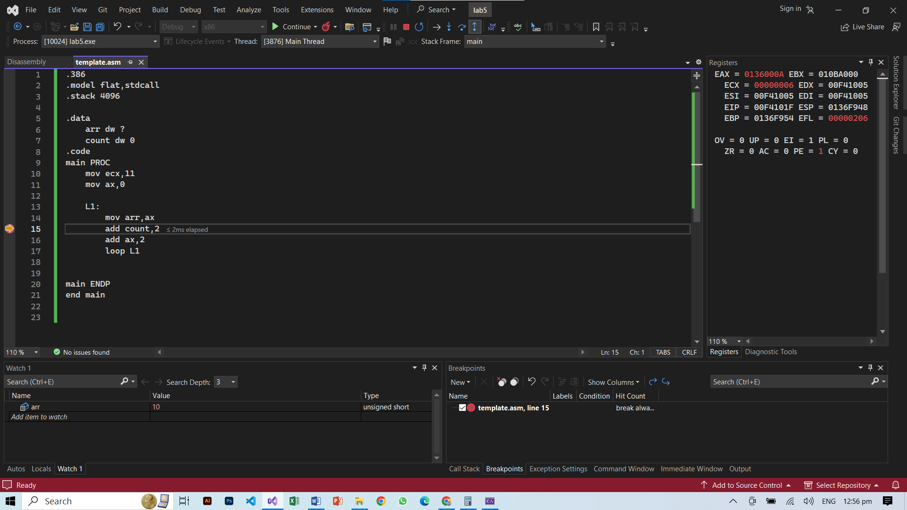 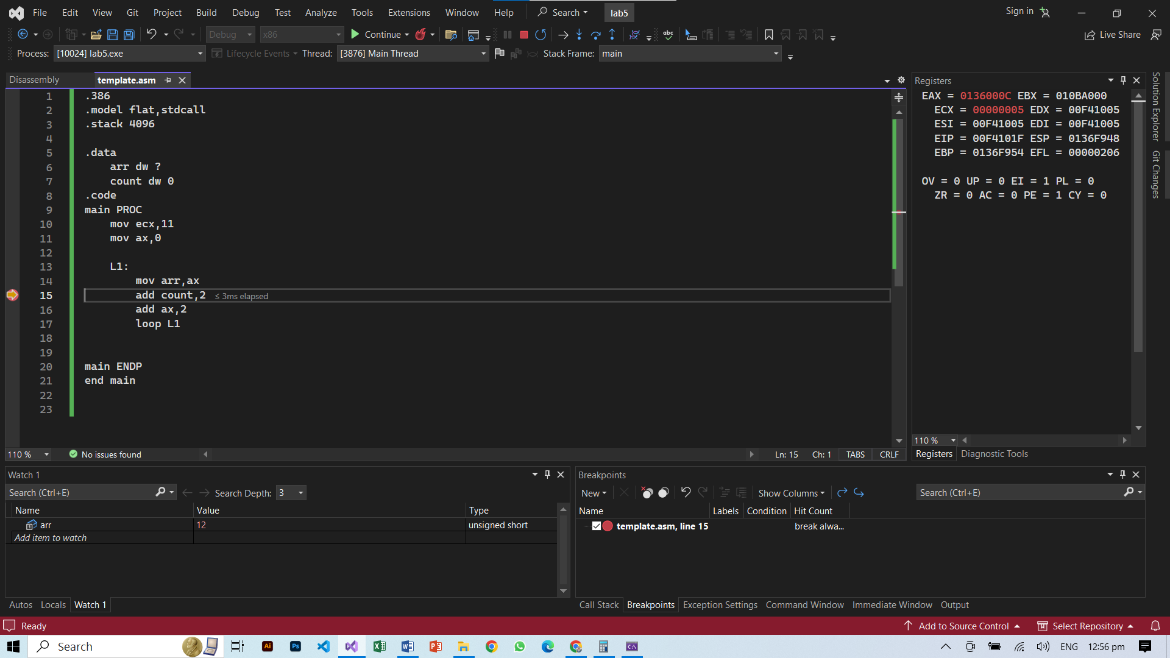 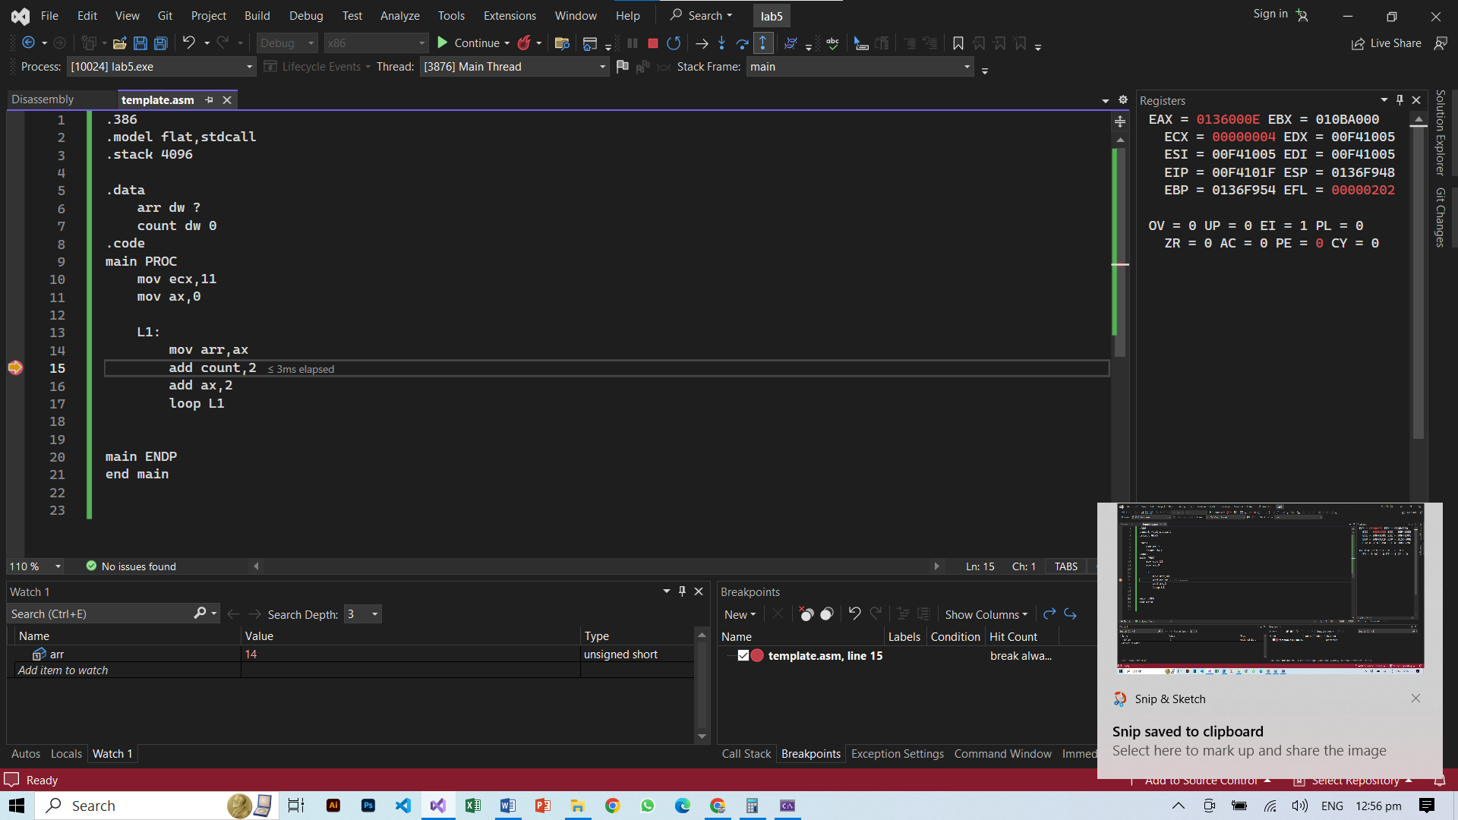 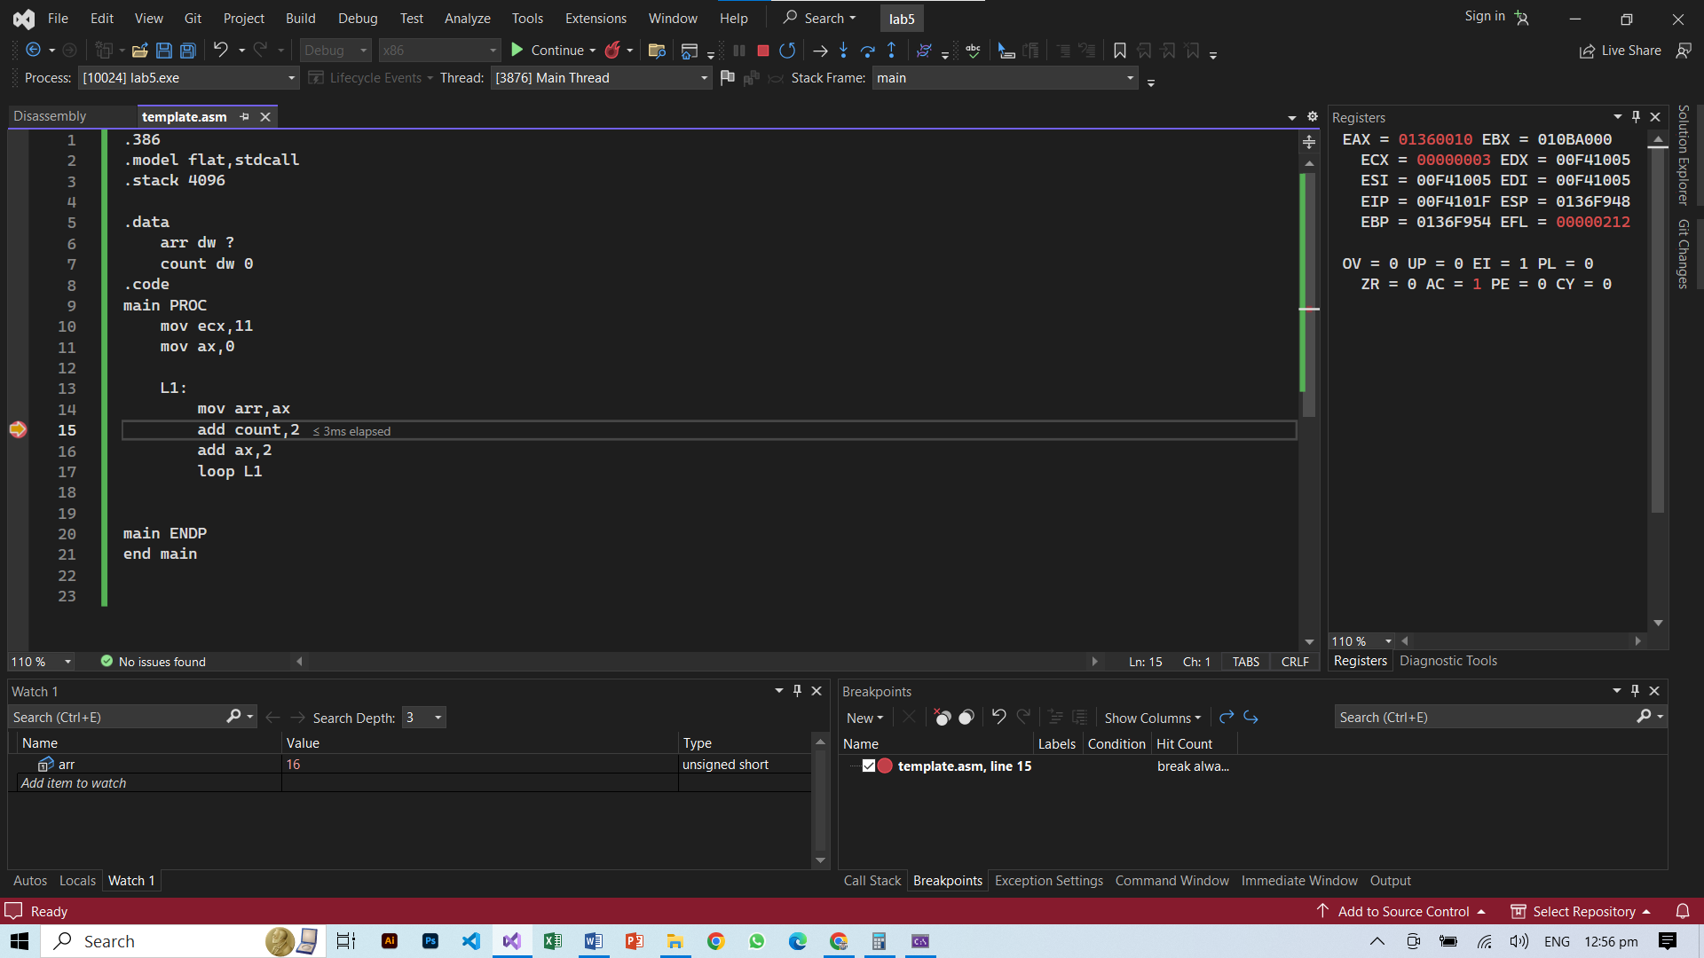 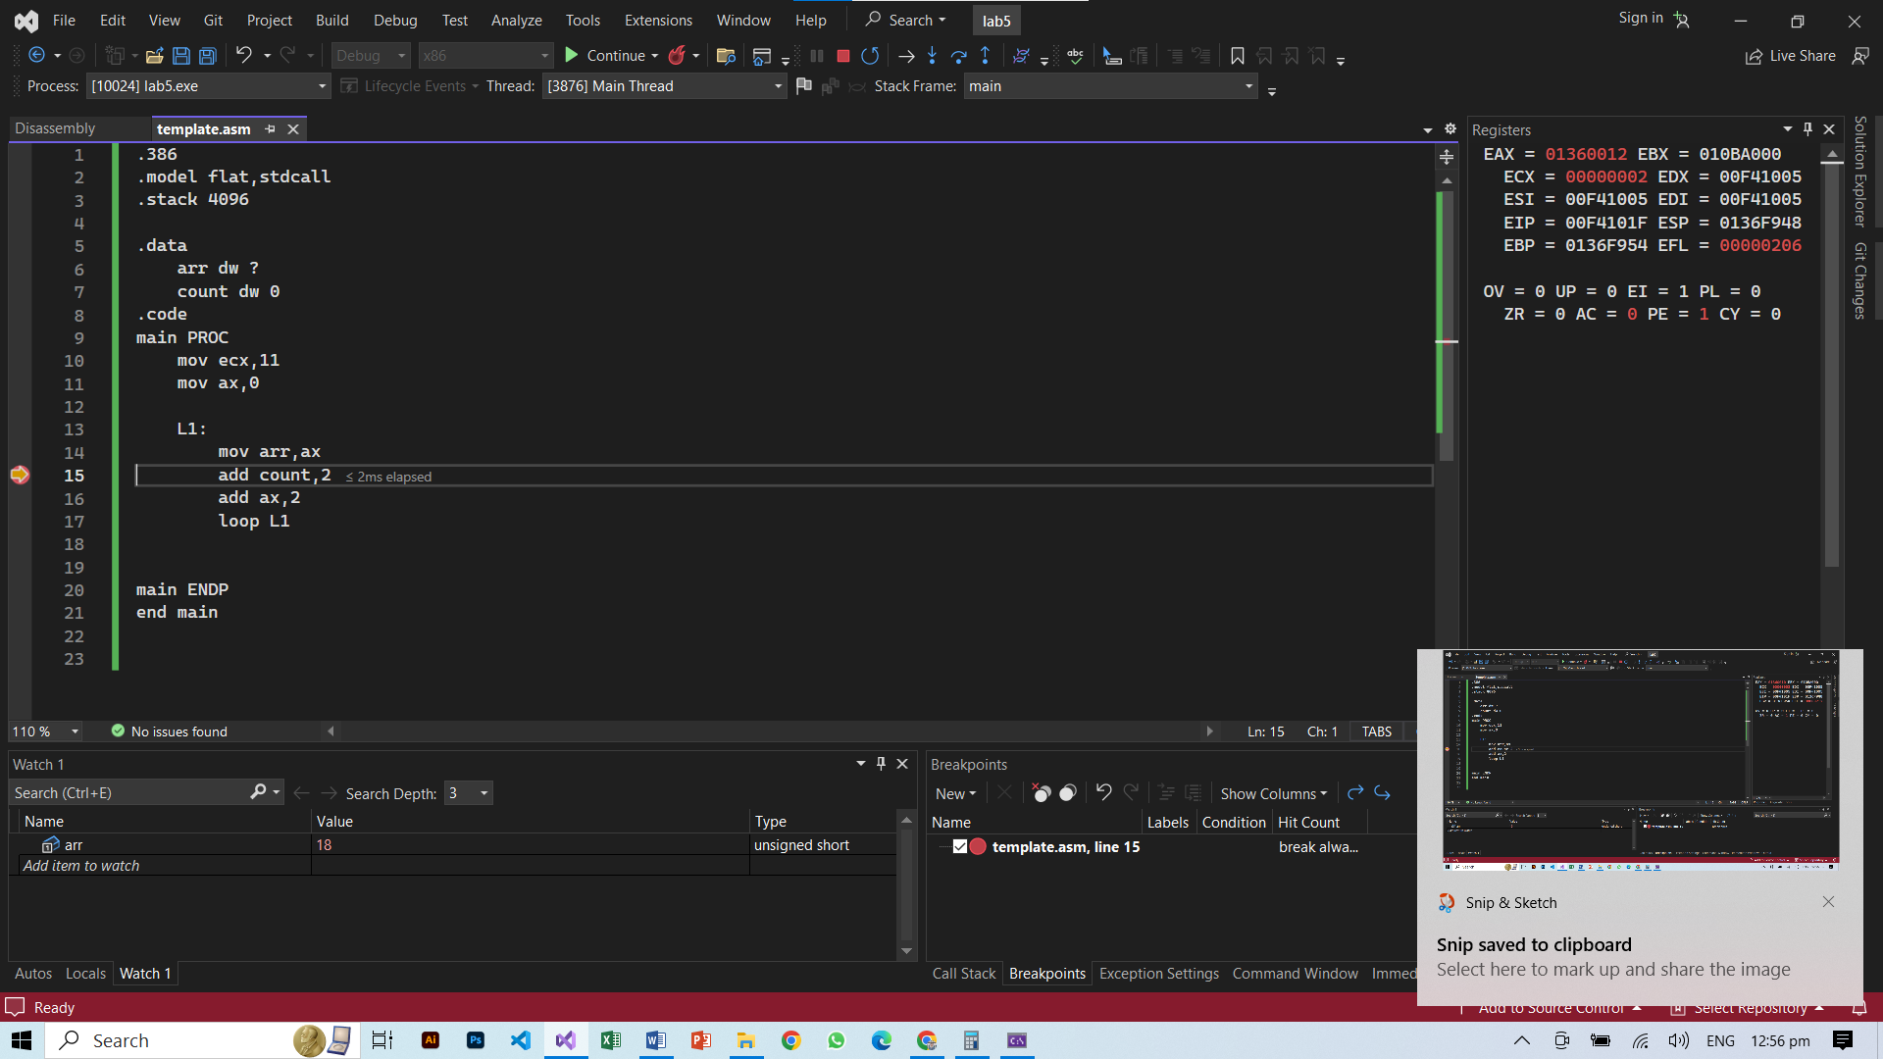

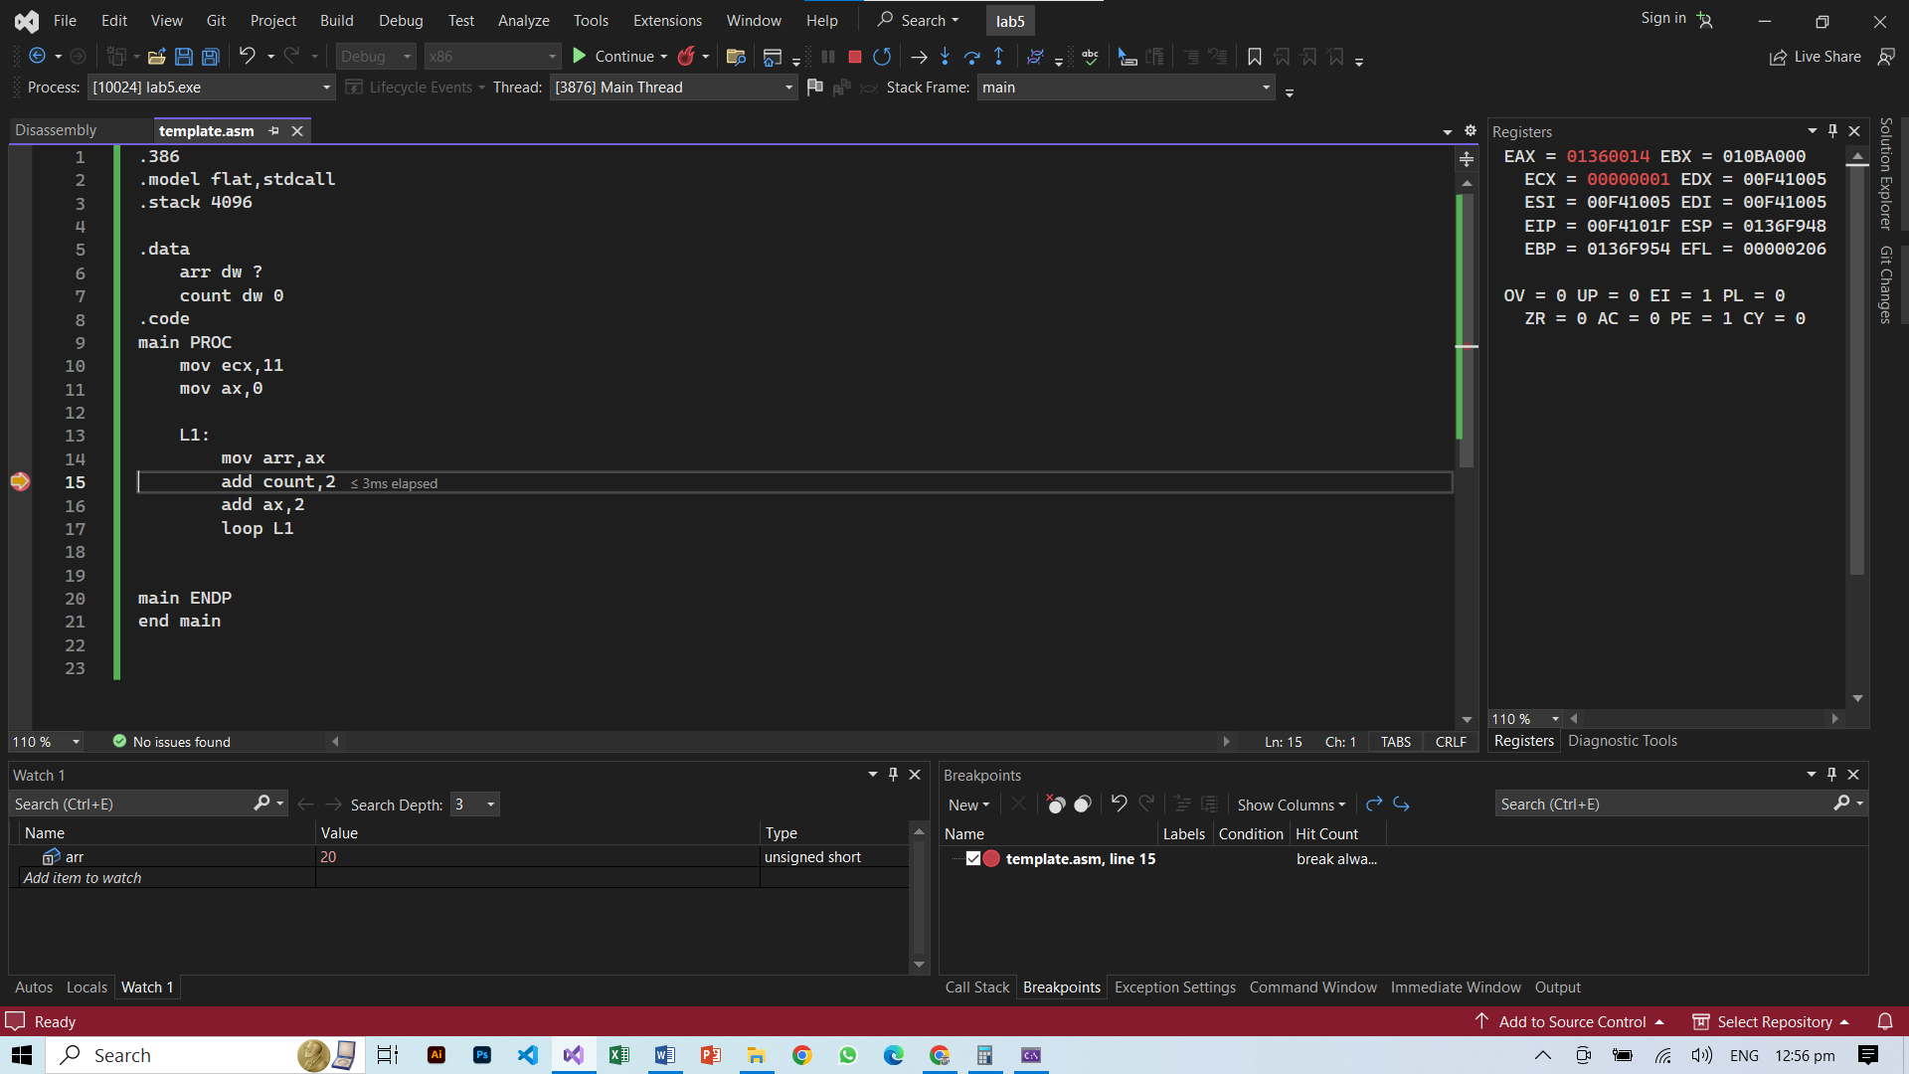

**Task 4**

.386

.model flat,stdcall

.stack 4096

.data

base dw 3

power dw 9 ; roll no 0900

.code

main PROC

mov eax,3

mov ecx,0

mov cx,power

mov bx,base

mov dx,base

L1:

mul bx

loop L1

main ENDP

end main

